Module Code | IY4113
Group | A
Module Title | Practical assignment part 1: Java Fundamentals
Assessment Type | Report
Module Tutor Name | Jonathan Shore
Student ID Number | P489062
Assessment Window | Final submission: 16/02/2026- 22/02/2026

☒ I confirm that this assignment is my own work. Where I have referred to academic sources, I have provided in-text citations and included the sources in the final reference list.

☒ Where I have used AI, I have cited and referenced appropriately.

Introduction

The purpose of this report is to chronicle the creation of a console-based public transport travel companion app that helps users keep track of fares, discounts and daily caps. This is to aid in the development of the app, ensuring that it does not grow too large in scope, and to enable reflection that shall allow for improvements during the later stages of development. The report shall keep track of any and all third-party code used, as well as all instrumental technical elements. Test tables and annotation screenshots shall be included in the report in order to demonstrate the program’s efficacy. The report shall start with the analysis conducted to identify core program functionality as well as expected inputs and outputs. Then, the algorithm and design used to infer the development of the program shall be explored, followed by a testing table that shows the expected and actual outputs from each of the inputs, and whether or not the program functions as intended. Finally, a full evaluation of the program’s efficacy and shortcomings shall be conducted.

Analysis

Purpose of the Program

Is to act as a public transport companion travel app that allows the user to keep track of their daily travels, allowing them to save the details of each individual journey, such as the starting zone, destination zone, whether the trip is during peak or off-peak times and the passenger type. The program shall calculate the base fare for the journey based on this information using a dataset, before applying any valid discounts or caps.

Core program functionality
- Manage journeys
  - Store multiple journeys, each with its own details (date, zones, passenger type, time band) as well as calculate the total.
  - Assign a unique ID to each journey
  - Display summaries such as total costs, averages, and category counts
- Display user menu
  - Show a simple menu that allows the user to choose what they'd like to do.
  - Have clear prompts to signify successful actions.
  - Loop the menu until the user exists
- Allow the user to manage journeys
  - Remove journeys from the list using its ID.
  - Add multiple journeys per session.
  - List all journeys.
  - Filter journeys by journey details (Zone, Time band).
  - Reset list.
- Validate inputs
  - Validate all information entered by the user.
  - Alert the user if any inputs are invalid.
- Enforce daily caps and discounts
  - Enforce daily cap and discounts for respective passenger types.
System constraints (limitations / rules)
- No persistence: journeys exist only while the program is running (no file/database use).
- Console UI only: interaction is via text menus and keyboard input.
- Daily cap and discounts: each passenger type (adult, student, child, senior citizen) has their own respective daily cap and discount rate.
- Information needed: All trip information is needed for the app to save the journey (e.g., starting zone, ending zone, passenger type).
- Booking rule: a booking can only succeed if all requested seats are valid and available.
- Scope constraint: journeys are tied only to zones, not to a mode of transport or specific location.
- Session uniqueness: journey IDs are generated to be unique during the run, but there’s no guarantee across separate runs since nothing is saved.

Input-Process-Output Table

Display main menu | User menu choice (0–7) | Validate input is an integer in range; route to chosen function | Confirmation of selected option / next screen shown
Add Journey | Date, TimeBand, StartZone, EndZone, PassengerType | Validate journey details; calculate and store: date, zones crossed, base fare, discounted fare (if applicable), fare after applying daily cap | Confirmation of journey details
Assign ID | Journey | Assign a unique ID to journey | None
List all journeys | Log | Load all journeys for the day, and their details | Display all journeys done that day in a list, showing each journey's details, as well as base fare, the discount applied and the charged fare
Filter journeys | Search condition (Passenger type, Time band, StartZone or EndZone, Date) | Filter all journeys by the input search condition | Display all journeys that match the filter input by the user.
Remove journey | JourneyID | Remove journey with matching ID from log and recalculate totals | Confirmation of journey removal and display new total OR "journey ID not found"
Reset day | Confirmation | Clear all journeys and totals from Log. | Confirm reset OR “No journeys recorded”
Round Values | Fares and Totals | Round all prices to 2 decimal points. | Rounded Numbers
Exit program | Menu choice = 0 | End loop; terminate program | “Goodbye!” message

Algorithm designs

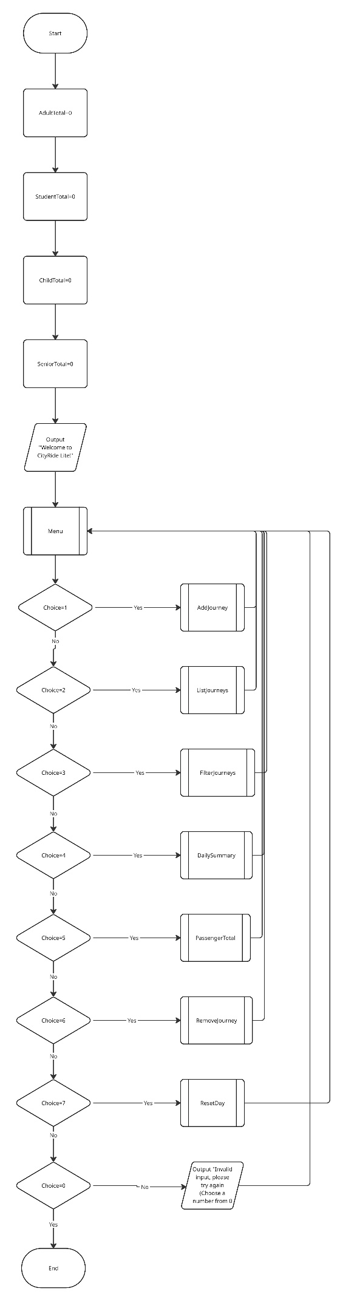
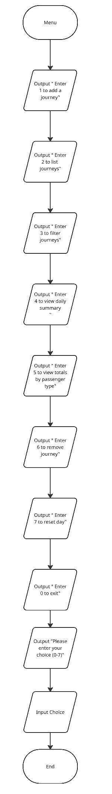
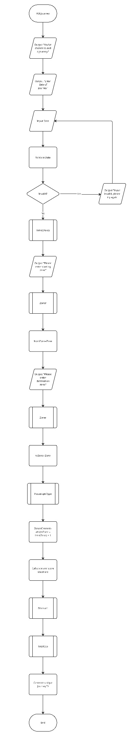
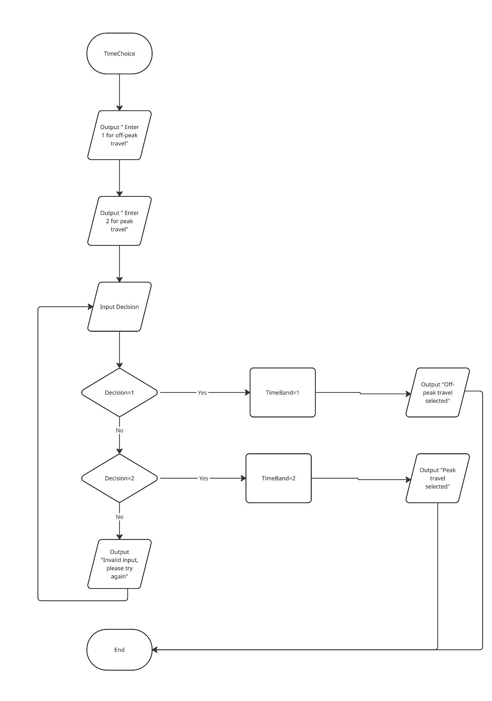

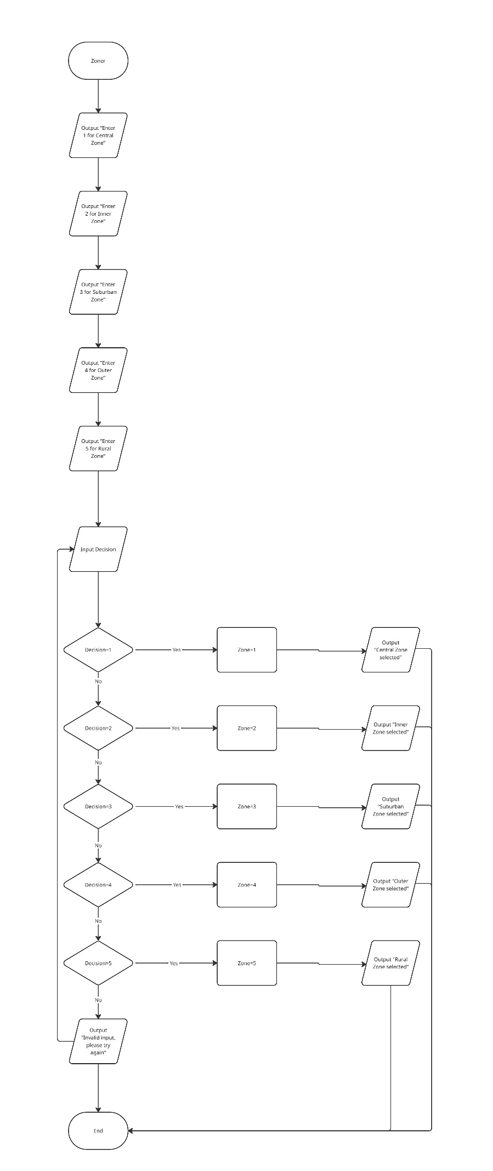
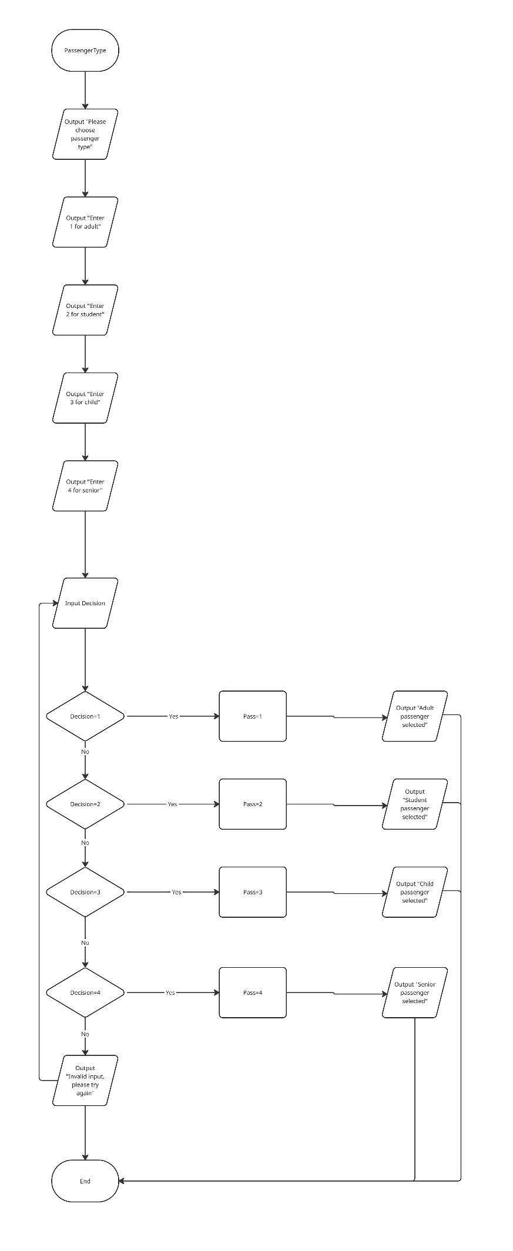
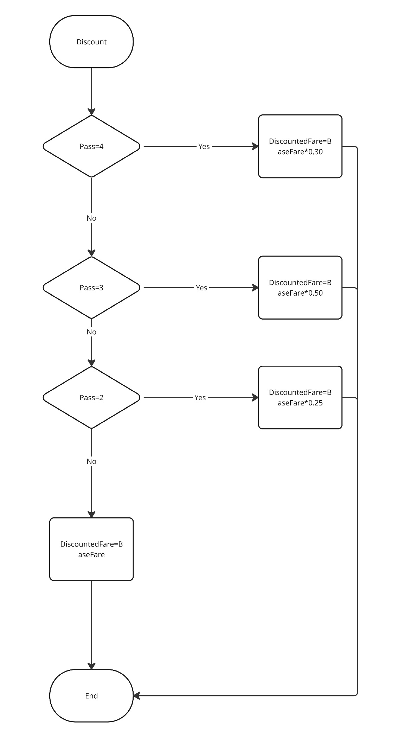
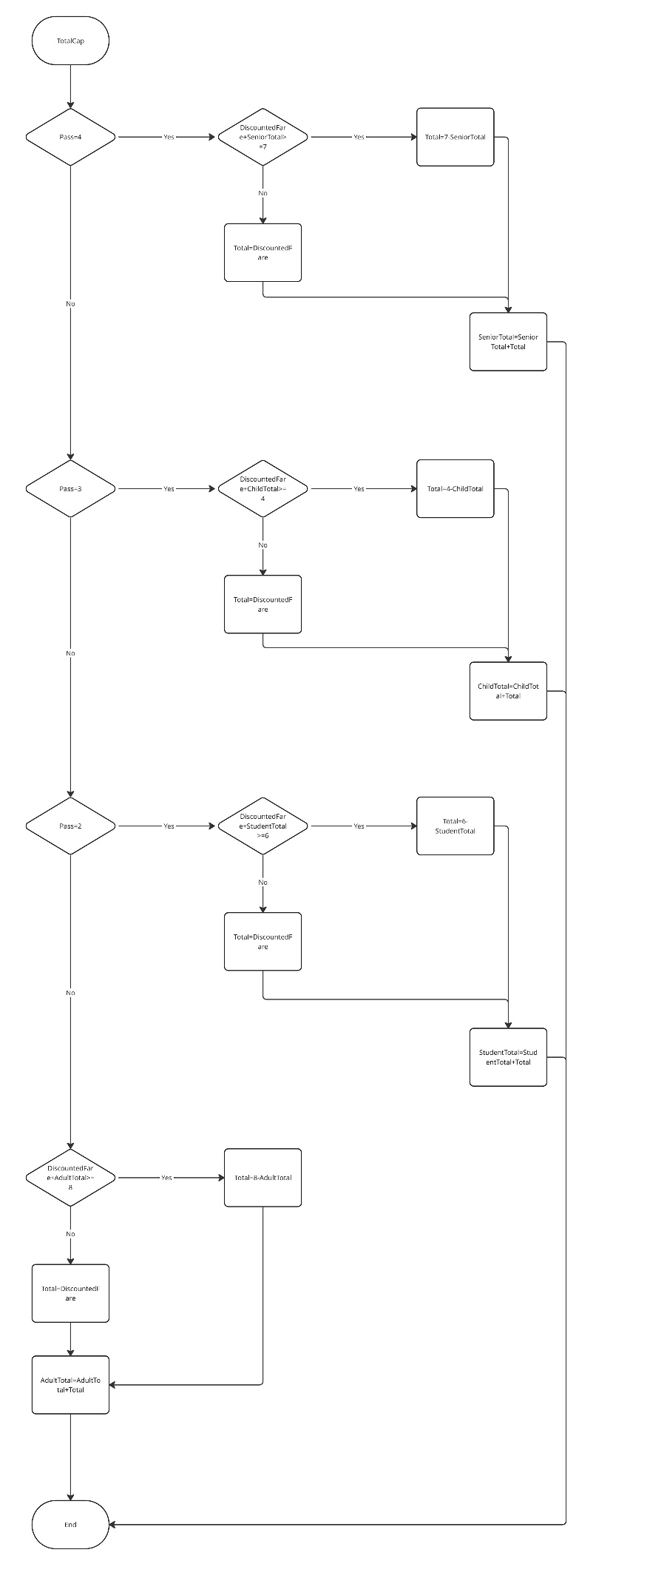
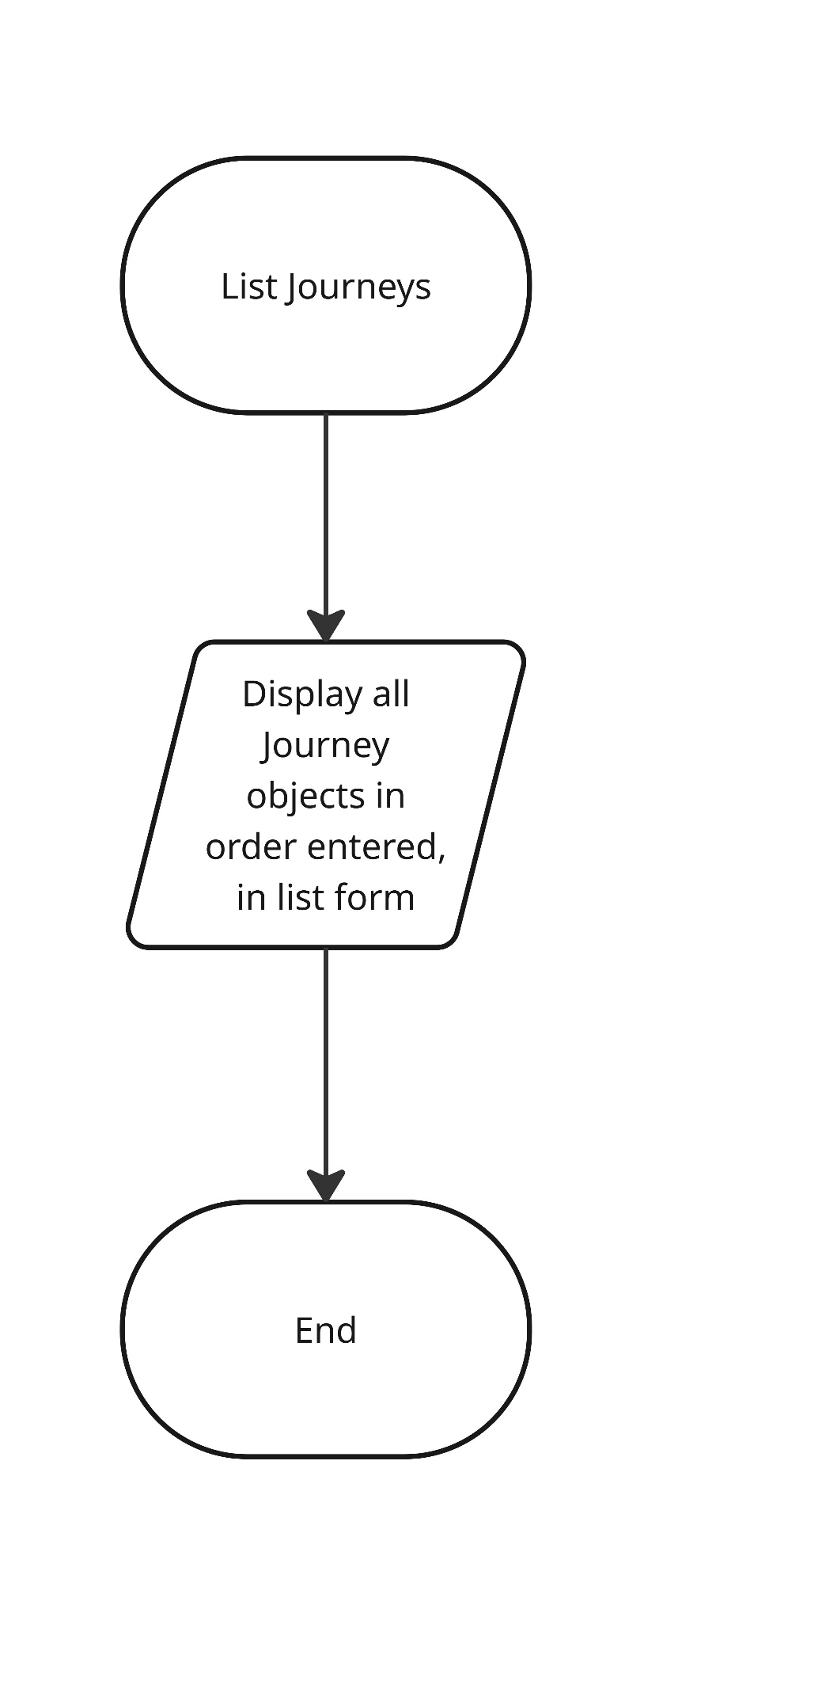
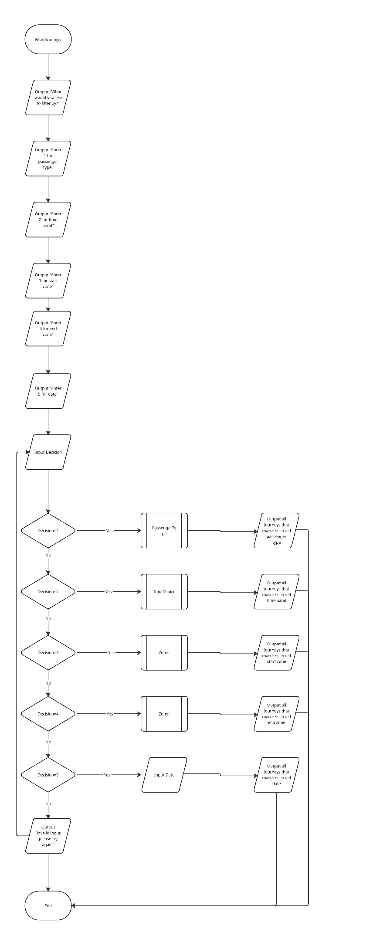
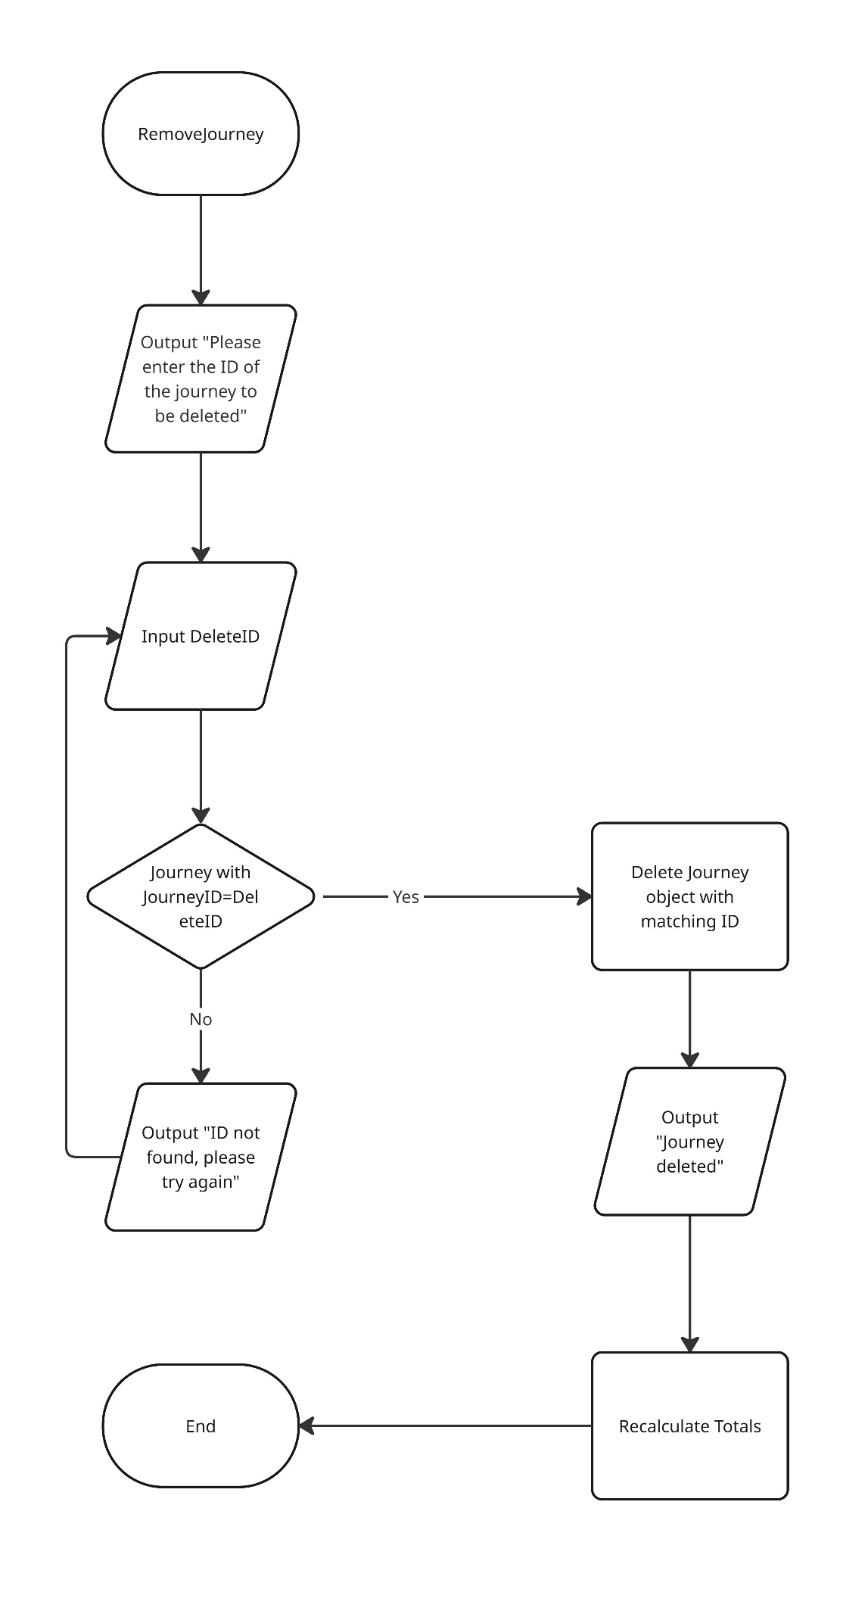
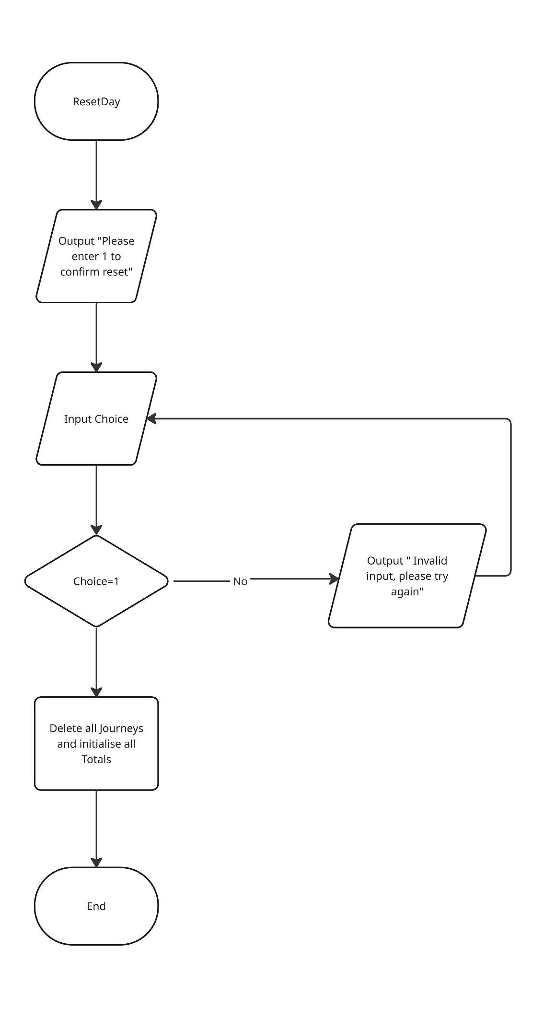
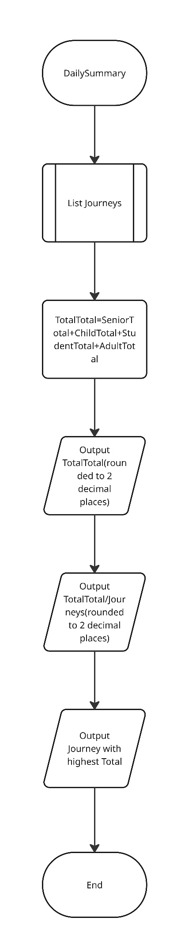
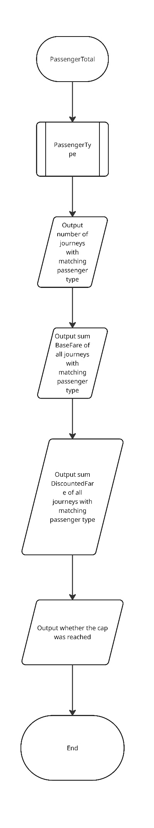

Testing

Currently, the program includes 32 user input prompts. If there were to be 5 tests conducted for each input that would result in 160 rows of tests, which is frankly obscene. As such, it has been decided to only conduct a small number of tests.

Test Number | Test | Test Description | Test Data | Expected Outcomes | Actual Outcome | Comments
1 | choice  (line 1102) | Valid Test | 3- integer | Program continues as expected | Program continues as expected | Test passes
2 | choice  (line 1102) | Invalid test | 10- integer | Program should respond with error message-Invalid choice, please try again | Program responds with error message Invalid choice, please try again | Test passes
3 | choice  (line 1102) | Extreme valid test | 5-integer | Program should continue as expected | Program continues as expected | Test passes
4 | choice  (line 1102) | Invalid extreme test | 50000-integer | Program should respond with an error message – Invalid choice, please try again | Program responds with error message Invalid choice, please try again | Test passes
5 | choice  (line 1102) | Error test | Kms-string | Program should respond with an error message – Please enter a valid choice | Program responds with an error message – Please enter a valid choice | Test passes
1 | ID (1037) | Valid test | 107307c3-bd01-4cff-971c-ac883b86a4fb-string | Program continues as expected with success message-journey has been deleted | Program continues as expected with success message-journey has been deleted | Test passes
2 | ID (1037) | Invalid test (using invalid ID) | 20456789-bd01-4cff-971c-ac883b86a4fb-string | Program should respond with an error message – Journey not found | Program responds with an error message – Journey not found | Test passes
3 | ID (1037) | Extreme invalid test | 1-string | Program should respond with an error message – Journey not found | Program responds with an error message – Journey not found | Test passes
4 | ID (1037) | Error test | Carriage return | Program should respond with an error message – Journey not found | Program responds with an error message – Journey not found | Test passes

Evaluation

It is believed that the program functions while covering all requirements, including but not limited to: adding journeys, showing all summaries, filtering journeys by specific attributes, deleting a journey, clearing the whole day’s journeys, displaying a daily summary with averages and counters, viewing individual summaries for each passenger type and looping until the user chooses to exist. The program also effectively enforces daily caps for each passenger type and updates running totals for passengers whenever relevant. Adequate use of functions and functional decomposition is observed, though the code could possibly be further optimised. The use of BigDecimal and UUID represents a much-appreciated boost to accuracy when calculating fares and generating journey IDs.

Code listing

import java.util.Scanner;
import java.util.ArrayList;
import java.util.List;
import java.time.*;
import java.util.UUID;
import java.math.BigDecimal;
import java.math.RoundingMode;
import java.util.HashMap;
import java.util.Map;
import java.math.*;
final class CityRideDataset {
private CityRideDataset() {}
public static final int MIN_ZONE = 1;
public static final int MAX_ZONE = 5;
public enum TimeBand {
PEAK,
OFF_PEAK
}
public enum PassengerType {
ADULT,
STUDENT,
CHILD,
SENIOR_CITIZEN
}
public static final Map<PassengerType, BigDecimal> DISCOUNT_RATE = Map.of(
PassengerType.ADULT, new BigDecimal("0.00"),
PassengerType.STUDENT, new BigDecimal("0.25"),
PassengerType.CHILD, new BigDecimal("0.50"),
PassengerType.SENIOR_CITIZEN, new BigDecimal("0.30")
);
public static final Map<PassengerType, BigDecimal> DAILY_CAP = Map.of(
PassengerType.ADULT, new BigDecimal("8.00"),
PassengerType.STUDENT, new BigDecimal("6.00"),
PassengerType.CHILD, new BigDecimal("4.00"),
PassengerType.SENIOR_CITIZEN, new BigDecimal("7.00")
);
public static final Map<String, BigDecimal> BASE_FARE = buildBaseFare();
public static BigDecimal getBaseFare(int fromZone, int toZone, TimeBand timeBand) {
return BASE_FARE.get(key(fromZone, toZone, timeBand));
}
public static String key(int fromZone, int toZone, TimeBand timeBand) {
return fromZone + "-" + toZone + "-" + timeBand.name();
}
private static BigDecimal money(String amount) {
return new BigDecimal(amount).setScale(2, RoundingMode.HALF_UP);
}
private static Map<String, BigDecimal> buildBaseFare() {
Map<String, BigDecimal> m = new HashMap<>();
// Peak fares
put(m,1,1,TimeBand.PEAK,"2.50"); put(m,1,2,TimeBand.PEAK,"3.20");
put(m,1,3,TimeBand.PEAK,"3.80"); put(m,1,4,TimeBand.PEAK,"4.40");
put(m,1,5,TimeBand.PEAK,"5.00");
put(m,2,1,TimeBand.PEAK,"3.20"); put(m,2,2,TimeBand.PEAK,"2.30");
put(m,2,3,TimeBand.PEAK,"3.10"); put(m,2,4,TimeBand.PEAK,"3.80");
put(m,2,5,TimeBand.PEAK,"4.50");
put(m,3,1,TimeBand.PEAK,"3.80"); put(m,3,2,TimeBand.PEAK,"3.10");
put(m,3,3,TimeBand.PEAK,"2.10"); put(m,3,4,TimeBand.PEAK,"3.00");
put(m,3,5,TimeBand.PEAK,"3.70");
put(m,4,1,TimeBand.PEAK,"4.40"); put(m,4,2,TimeBand.PEAK,"3.80");
put(m,4,3,TimeBand.PEAK,"3.00"); put(m,4,4,TimeBand.PEAK,"2.00");
put(m,4,5,TimeBand.PEAK,"2.90");
put(m,5,1,TimeBand.PEAK,"5.00"); put(m,5,2,TimeBand.PEAK,"4.50");
put(m,5,3,TimeBand.PEAK,"3.70"); put(m,5,4,TimeBand.PEAK,"2.90");
put(m,5,5,TimeBand.PEAK,"1.90");
// Off-peak fares
put(m,1,1,TimeBand.OFF_PEAK,"2.00"); put(m,1,2,TimeBand.OFF_PEAK,"2.70");
put(m,1,3,TimeBand.OFF_PEAK,"3.20"); put(m,1,4,TimeBand.OFF_PEAK,"3.70");
put(m,1,5,TimeBand.OFF_PEAK,"4.20");
put(m,2,1,TimeBand.OFF_PEAK,"2.70"); put(m,2,2,TimeBand.OFF_PEAK,"1.90");
put(m,2,3,TimeBand.OFF_PEAK,"2.60"); put(m,2,4,TimeBand.OFF_PEAK,"3.20");
put(m,2,5,TimeBand.OFF_PEAK,"3.80");
put(m,3,1,TimeBand.OFF_PEAK,"3.20"); put(m,3,2,TimeBand.OFF_PEAK,"2.60");
put(m,3,3,TimeBand.OFF_PEAK,"1.70"); put(m,3,4,TimeBand.OFF_PEAK,"2.50");
put(m,3,5,TimeBand.OFF_PEAK,"3.10");
put(m,4,1,TimeBand.OFF_PEAK,"3.70"); put(m,4,2,TimeBand.OFF_PEAK,"3.20");
put(m,4,3,TimeBand.OFF_PEAK,"2.50"); put(m,4,4,TimeBand.OFF_PEAK,"1.60");
put(m,4,5,TimeBand.OFF_PEAK,"2.40");
put(m,5,1,TimeBand.OFF_PEAK,"4.20"); put(m,5,2,TimeBand.OFF_PEAK,"3.80");
put(m,5,3,TimeBand.OFF_PEAK,"3.10"); put(m,5,4,TimeBand.OFF_PEAK,"2.40");
put(m,5,5,TimeBand.OFF_PEAK,"1.50");
return Map.copyOf(m);
}
private static void put(Map<String, BigDecimal> m, int from, int to, TimeBand band, String amount) {
m.put(key(from, to, band), money(amount));
}
}
class Journey {
private CityRideDataset.TimeBand journeyTime;
private LocalDate journeyDate;
private int startZone;
private int endZone;
private CityRideDataset.PassengerType passenger;
private BigDecimal baseFare;
private BigDecimal discountFare;
private BigDecimal finalFare;
private String journeyID;
private BigDecimal total;
public Journey(Scanner scanner){
journeyTime = chooseTime(scanner, "Please choose timeband");
journeyDate =LocalDate.now();
startZone = chooseZone(scanner, "Please choose starting zone");
endZone = chooseZone(scanner, "Please choose destination zone");
passenger = choosePassenger(scanner, "Please choose passenger type");
baseFare= CityRideDataset.getBaseFare(startZone,endZone,journeyTime);//Base fare will be calculated once dataset is made available
discountFare=discount();
finalFare=finalFare();
journeyID = UUID.randomUUID().toString();
}
public CityRideDataset.TimeBand chooseTime(Scanner scanner, String message) {
boolean valid = false;
int choice;
CityRideDataset.TimeBand timeBand= CityRideDataset.TimeBand.PEAK;
System.out.println(message);
System.out.println("Enter 1 for Peak-time travel");
System.out.println("Enter 2 for Off-peak travel");
System.out.println("Choice: ");
while (valid == false) {
try {
choice = scanner.nextInt();
scanner.nextLine();
switch (choice) {
case 1:
timeBand = CityRideDataset.TimeBand.PEAK;
valid = true;
break;
case 2:
timeBand = CityRideDataset.TimeBand.OFF_PEAK;
valid = true;
break;
default:
System.out.println("Invalid choice, please try again");
break;
}
}
catch(Exception e){
System.out.println("Please enter a valid choice");
scanner.nextLine();
}
}
return timeBand;
}
public int chooseZone(Scanner scanner, String message){
boolean valid=false;
int choice=0;
System.out.println(message);
System.out.println("Enter 1 for Central Zone");
System.out.println("Enter 2 for Inner Zone");
System.out.println("Enter 3 for Suburban Zone");
System.out.println("Enter 4 for Outer Zone");
System.out.println("Enter 5 for Rural Zone");
System.out.println("Choice: ");
while (valid==false) {
try {
choice = scanner.nextInt();
scanner.nextLine();
if (choice >= CityRideDataset.MIN_ZONE && choice <= CityRideDataset.MAX_ZONE) {
valid = true;
} else {
System.out.println("Invalid choice, please try again");
choice = scanner.nextInt();
scanner.nextLine();
}
}
catch (Exception e){
System.out.println("Please enter a valid choice");
scanner.nextLine();
}
}
return choice;
}
public CityRideDataset.PassengerType choosePassenger(Scanner scanner, String message){
boolean valid=false;
int choice;
CityRideDataset.PassengerType passenger = CityRideDataset.PassengerType.ADULT;
System.out.println(message);
System.out.println("Enter 1 for Adult passenger");
System.out.println("Enter 2 for Student passenger");
System.out.println("Enter 3 for Child passenger");
System.out.println("Enter 4 for Senior passenger");
System.out.println("Choice: ");
while (valid==false) {
try {
choice = scanner.nextInt();
scanner.nextLine();
switch (choice) {
case 1:
passenger = CityRideDataset.PassengerType.ADULT;
valid = true;
break;
case 2:
passenger = CityRideDataset.PassengerType.STUDENT;
valid = true;
break;
case 3:
passenger = CityRideDataset.PassengerType.CHILD;
valid = true;
break;
case 4:
passenger = CityRideDataset.PassengerType.SENIOR_CITIZEN;
valid = true;
break;
default:
System.out.println("Invalid choice, please try again");
choice = scanner.nextInt();
scanner.nextLine();
}
}
catch (Exception e){
System.out.println("Please enter a valid choice");
scanner.nextLine();
}
}
return passenger;
}
public BigDecimal discount(){
BigDecimal discountfare;
discountfare=(baseFare.subtract(CityRideDataset.DISCOUNT_RATE.get(passenger).multiply(baseFare))).setScale(2, RoundingMode.HALF_UP);
return discountfare;
}
public BigDecimal finalFare() {
if (((discountFare.add(journeyList.PASSENGER_TOTAL.get(getPassenger()))).compareTo(CityRideDataset.DAILY_CAP.get(getPassenger()))) >= 0) {
finalFare = (CityRideDataset.DAILY_CAP.get(getPassenger())).subtract(journeyList.PASSENGER_TOTAL.get(getPassenger()));
}
else{
finalFare=discountFare;
}
journeyList.PASSENGER_TOTAL.put(passenger,journeyList.PASSENGER_TOTAL.get(passenger).add(finalFare));
return finalFare;
}
public CityRideDataset.TimeBand getJourneyTime(){
return journeyTime;
}
public LocalDate getJourneyDate(){
return journeyDate;
}
public int getStartZone(){
return startZone;
} public int getEndZone(){
return endZone;
}
public CityRideDataset.PassengerType getPassenger(){
return passenger;
}
public BigDecimal getBaseFare(){
return baseFare;
}
public BigDecimal getDiscountFare(){
return discountFare;
}
public BigDecimal getFinalFare(){
return finalFare;
}
public String getJourneyID(){
return journeyID;
}
public void setJourneyTime(Scanner scanner){
this.journeyTime = chooseTime(scanner, "Please choose travel time" );
}
public void setJourneyDate(){
this.journeyDate =LocalDate.now();
}
public void setStartZone(Scanner scanner){
this.startZone =chooseZone(scanner,"Please choose starting zone" );
}
public void setEndZone(Scanner scanner){
this.endZone =chooseZone(scanner,"Please choose starting zone");
}
public void setPassenger(Scanner scanner){
this.passenger =choosePassenger(scanner, "Please choose passenger type");
}
public void setBaseFare(){
this.baseFare = CityRideDataset.getBaseFare(startZone, endZone, journeyTime);
}
public void setDiscountFare(){
this.discountFare = discount();
}
public void setFinalFare(){
this.finalFare = finalFare();
}
public void displayDetails(){
System.out.println("[" + journeyDate + "] Time: "+ journeyTime + "| Starting Zone: " + startZone + "| Destination Zone: " + endZone + "| Zones Crossed: " + (Math.abs(endZone - startZone) + 1) + "| Passenger Type: " + passenger + " | Base Fare: £" + baseFare + "| Discount Applied: "+ CityRideDataset.DISCOUNT_RATE.get(passenger).movePointRight(2).setScale(0, RoundingMode.HALF_UP) + "% | Discounted Fare: £" + discountFare + "| Final Fare: £" + finalFare + "| Journey ID: " + journeyID);
}
}
class journeyList {
private List<Journey> journeyList = new ArrayList<>();
public static Map<CityRideDataset.PassengerType, BigDecimal> PASSENGER_TOTAL = new HashMap<>();
static {
PASSENGER_TOTAL.put(CityRideDataset.PassengerType.ADULT, new BigDecimal("0.00"));
PASSENGER_TOTAL.put(CityRideDataset.PassengerType.STUDENT, new BigDecimal("0.00"));
PASSENGER_TOTAL.put(CityRideDataset.PassengerType.CHILD, new BigDecimal("0.00"));
PASSENGER_TOTAL.put(CityRideDataset.PassengerType.SENIOR_CITIZEN, new BigDecimal("0.00"));
}
public void addJourney(Journey c){
journeyList.add(c);
System.out.println("Journey with ID: " + c.getJourneyID() + " has been added.");
}
public Journey findJourneyByID(String ID){
for(Journey c : journeyList){
if(c.getJourneyID().equalsIgnoreCase(ID)){
return c;
}
}
return null;
}
public void filterPassenger(Scanner scanner){
boolean valid = false;
int choice;
System.out.println("Please choose passenger to search for:");
System.out.println("1. Adult");
System.out.println("2. Student");
System.out.println("3. Child");
System.out.println("4. Senior");
System.out.println("Please enter choice (1-4): ");
while (valid==false) {
try {
choice = scanner.nextInt();
scanner.nextLine();
switch (choice) {
case 1:
if (journeyList.isEmpty()) {
System.out.println("Journey list is empty.");
}
else{
boolean found=false;
for(Journey c : journeyList) {
if (c.getPassenger()== CityRideDataset.PassengerType.ADULT) {
found=true;
c.displayDetails();
}
}
if (found==false){
System.out.println("No matches found.");
}
}
valid = true;
break;
case 2:
if (journeyList.isEmpty()) {
System.out.println("Journey list is empty.");
}
else{
boolean found=false;
for(Journey c : journeyList) {
if (c.getPassenger()== CityRideDataset.PassengerType.STUDENT) {
found=true;
c.displayDetails();
}
}
if (found==false){
System.out.println("No matches found.");
}
}
valid = true;
break;
case 3:
if (journeyList.isEmpty()) {
System.out.println("Journey list is empty.");
}
else{
boolean found=false;
for(Journey c : journeyList) {
if (c.getPassenger()== CityRideDataset.PassengerType.CHILD) {
found=true;
c.displayDetails();
}
}
if (found==false){
System.out.println("No matches found.");
}
}
valid = true;
break;
case 4:
if (journeyList.isEmpty()) {
System.out.println("Journey list is empty.");
}
else{
boolean found=false;
for(Journey c : journeyList) {
if (c.getPassenger()== CityRideDataset.PassengerType.SENIOR_CITIZEN) {
found=true;
c.displayDetails();
}
}
if (found==false){
System.out.println("No matches found.");
}
}
valid = true;
break;
default:
System.out.println("Invalid choice, please try again");
choice = scanner.nextInt();
scanner.nextLine();
}
} catch (Exception e) {
System.out.println("Please enter a valid choice");
scanner.nextLine();
}
}
}
public void filterTime(Scanner scanner){
boolean valid = false;
int choice;
System.out.println("Please choose time-band to search for:");
System.out.println("1. Peak");
System.out.println("2. Off-Peak");
System.out.println("Please enter choice (1-2): ");
while (valid==false) {
try {
choice = scanner.nextInt();
scanner.nextLine();
switch (choice) {
case 1:
if (journeyList.isEmpty()) {
System.out.println("Journey list is empty.");
}
else{
boolean found=false;
for(Journey c : journeyList) {
if (c.getJourneyTime()== CityRideDataset.TimeBand.PEAK) {
found=true;
c.displayDetails();
}
}
if (found==false){
System.out.println("No matches found.");
}
}
valid = true;
break;
case 2:
if (journeyList.isEmpty()) {
System.out.println("Journey list is empty.");
}
else{
boolean found=false;
for(Journey c : journeyList) {
if (c.getJourneyTime()== CityRideDataset.TimeBand.OFF_PEAK) {
found=true;
c.displayDetails();
}
}
if (found==false){
System.out.println("No matches found.");
}
}
valid = true;
break;
default:
System.out.println("Invalid choice, please try again");
choice = scanner.nextInt();
scanner.nextLine();
}
} catch (Exception e) {
System.out.println("Please enter a valid choice");
scanner.nextLine();
}
}
}
public void filterStartZone(Scanner scanner){
boolean valid = false;
int choice;
System.out.println("Please choose zone to search for:");
System.out.println("Enter 1 for Central Zone");
System.out.println("Enter 2 for Inner Zone");
System.out.println("Enter 3 for Suburban Zone");
System.out.println("Enter 4 for Outer Zone");
System.out.println("Enter 5 for Rural Zone");
System.out.println("Choice: ");
while (valid==false) {
try {
choice = scanner.nextInt();
scanner.nextLine();
switch (choice) {
case 1:
if (journeyList.isEmpty()) {
System.out.println("Journey list is empty.");
}
else{
boolean found=false;
for(Journey c : journeyList) {
if (c.getStartZone()== 1) {
found=true;
c.displayDetails();
}
}
if (found==false){
System.out.println("No matches found.");
}
}
valid = true;
break;
case 2:
if (journeyList.isEmpty()) {
System.out.println("Journey list is empty.");
}
else{
boolean found=false;
for(Journey c : journeyList) {
if (c.getStartZone()== 2) {
found=true;
c.displayDetails();
}
}
if (found==false){
System.out.println("No matches found.");
}
}
valid = true;
break;
case 3:
if (journeyList.isEmpty()) {
System.out.println("Journey list is empty.");
}
else{
boolean found=false;
for(Journey c : journeyList) {
if (c.getStartZone()== 3) {
found=true;
c.displayDetails();
}
}
if (found==false){
System.out.println("No matches found.");
}
}
valid = true;
break;
case 4:
if (journeyList.isEmpty()) {
System.out.println("Journey list is empty.");
}
else{
boolean found=false;
for(Journey c : journeyList) {
if (c.getStartZone()== 4) {
found=true;
c.displayDetails();
}
}
if (found==false){
System.out.println("No matches found.");
}
}
valid = true;
break;
case 5:
if (journeyList.isEmpty()) {
System.out.println("Journey list is empty.");
}
else{
boolean found=false;
for(Journey c : journeyList) {
if (c.getStartZone()== 5) {
found=true;
c.displayDetails();
}
}
if (found==false){
System.out.println("No matches found.");
}
}
valid = true;
break;
default:
System.out.println("Invalid choice, please try again");
choice = scanner.nextInt();
scanner.nextLine();
}
} catch (Exception e) {
System.out.println("Please enter a valid choice");
scanner.nextLine();
}
}
}
public void filterEndZone(Scanner scanner){
boolean valid = false;
int choice;
System.out.println("Please choose zone to search for:");
System.out.println("Enter 1 for Central Zone");
System.out.println("Enter 2 for Inner Zone");
System.out.println("Enter 3 for Suburban Zone");
System.out.println("Enter 4 for Outer Zone");
System.out.println("Enter 5 for Rural Zone");
System.out.println("Choice: ");
while (valid==false) {
try {
choice = scanner.nextInt();
scanner.nextLine();
switch (choice) {
case 1:
if (journeyList.isEmpty()) {
System.out.println("Journey list is empty.");
}
else{
boolean found=false;
for(Journey c : journeyList) {
if (c.getEndZone()== 1) {
found=true;
c.displayDetails();
}
}
if (found==false){
System.out.println("No matches found.");
}
}
valid = true;
break;
case 2:
if (journeyList.isEmpty()) {
System.out.println("Journey list is empty.");
}
else{
boolean found=false;
for(Journey c : journeyList) {
if (c.getEndZone()== 2) {
found=true;
c.displayDetails();
}
}
if (found==false){
System.out.println("No matches found.");
}
}
valid = true;
break;
case 3:
if (journeyList.isEmpty()) {
System.out.println("Journey list is empty.");
}
else{
boolean found=false;
for(Journey c : journeyList) {
if (c.getEndZone()== 3) {
found=true;
c.displayDetails();
}
}
if (found==false){
System.out.println("No matches found.");
}
}
valid = true;
break;
case 4:
if (journeyList.isEmpty()) {
System.out.println("Journey list is empty.");
}
else{
boolean found=false;
for(Journey c : journeyList) {
if (c.getEndZone()== 4) {
found=true;
c.displayDetails();
}
}
if (found==false){
System.out.println("No matches found.");
}
}
valid = true;
break;
case 5:
if (journeyList.isEmpty()) {
System.out.println("Journey list is empty.");
}
else{
boolean found=false;
for(Journey c : journeyList) {
if (c.getEndZone()== 5) {
found=true;
c.displayDetails();
}
}
if (found==false){
System.out.println("No matches found.");
}
}
valid = true;
break;
default:
System.out.println("Invalid choice, please try again");
choice = scanner.nextInt();
scanner.nextLine();
}
} catch (Exception e) {
System.out.println("Please enter a valid choice");
scanner.nextLine();
}
}
}
public void filterDate(Scanner scanner) {
System.out.println("Please enter date to search for:");
boolean valid = false;
while (valid == false) {
try {
System.out.println("Please enter day (dd): ");
String day = scanner.nextLine();
System.out.println("Please enter month (MM): ");
String month = scanner.nextLine();
System.out.println("Please enter year (yyyy): ");
String year = scanner.nextLine();
String date= year + "-" + month + "-" + day;
boolean found=false;
for(Journey c : journeyList) {
if (c.getJourneyDate().toString()== date) {
found=true;
c.displayDetails();
}
}
if (found==false){
System.out.println("No matches found.");
}
valid = true;
} catch (Exception e) {
System.out.println("Please enter a valid choice");
scanner.nextLine();
}
}
}
public void filterJourney(Scanner scanner){
boolean valid = false;
int choice;
System.out.println("Please choose filter category:");
System.out.println("1. Passenger Type");
System.out.println("2. Time Band");
System.out.println("3. Start Zone");
System.out.println("4. End Zone");
System.out.println("5. Date");
System.out.println("Please enter choice (1-5): ");
while (valid==false) {
try {
choice = scanner.nextInt();
scanner.nextLine();
switch (choice) {
case 1:
filterPassenger(scanner);
valid = true;
break;
case 2:
filterTime(scanner);
valid = true;
break;
case 3:
filterStartZone(scanner);
valid = true;
break;
case 4:
filterEndZone(scanner);
valid = true;
break;
case 5:
filterDate(scanner);
valid = true;
break;
default:
System.out.println("Invalid choice, please try again");
choice = scanner.nextInt();
scanner.nextLine();
}
} catch (Exception e) {
System.out.println("Please enter a valid choice");
scanner.nextLine();
}
}
}
public void dailySummary(Scanner scanner){
int journeyCount=0;
String highestJourneyID="";
BigDecimal totalCost= new BigDecimal(0);
BigDecimal highestFare= new BigDecimal(0);
int peakCounter=0;
int offPeakCounter=0;
int zone1counter=0;
int zone2counter=0;
int zone3counter=0;
int zone4counter=0;
int zone5counter=0;
if (journeyList.isEmpty()) {
System.out.println("Journey list is empty.");
}
else {
for (Journey c : journeyList) {
journeyCount = journeyCount + 1;
totalCost = totalCost.add(c.getFinalFare());
if (c.getFinalFare().compareTo(highestFare) > 0) {
highestJourneyID = c.getJourneyID();
highestFare = c.getFinalFare();
}
if (c.getJourneyTime()== CityRideDataset.TimeBand.PEAK){
peakCounter+=1;
}
else {
offPeakCounter+=1;
}
if (c.getEndZone()==1 || c.getStartZone()==1){
zone1counter+=1;
}
if (c.getEndZone()==2 || c.getStartZone()==2){
zone2counter+=1;
}
if (c.getEndZone()==3 || c.getStartZone()==3){
zone3counter+=1;
}
if (c.getEndZone()==4 || c.getStartZone()==4){
zone4counter+=1;
}
if (c.getEndZone()==5 || c.getStartZone()==5){
zone5counter+=1;
}
}
System.out.println("Total number of journeys: " + journeyCount);
System.out.println("Total cost: " + totalCost);
System.out.println("Average fare : " + (totalCost.divide(new BigDecimal(journeyCount))).setScale(2, RoundingMode.HALF_UP));
System.out.println("Highest Fare: " + highestFare + " with journey ID: " + highestJourneyID);
System.out.println("Number of peak journeys: " + peakCounter);
System.out.println("Number of off-peak journeys: " + offPeakCounter);
System.out.println("Number of journeys to/from Central Zone: " + zone1counter);
System.out.println("Number of journeys to/from Inner Zone: " + zone2counter);
System.out.println("Number of journeys to/from Suburban Zone: " + zone3counter);
System.out.println("Number of journeys to/from Outer Zone: " + zone4counter);
System.out.println("Number of journeys to/from Rural Zone: " + zone5counter);
}
}
public void passengerSummary(Scanner scanner){
int journeyCount=0;
BigDecimal preDiscountSum=new BigDecimal(0);
BigDecimal discountedSum=new BigDecimal(0);
BigDecimal chargedSum=new BigDecimal(0);
if (journeyList.isEmpty()) {
System.out.println("Journey list is empty.");
}
else{
boolean found=false;
for(Journey c : journeyList) {
if (c.getPassenger()==CityRideDataset.PassengerType.ADULT){
journeyCount=journeyCount+1;
preDiscountSum=preDiscountSum.add(c.getBaseFare());
discountedSum=discountedSum.add(c.getDiscountFare());
chargedSum=chargedSum.add(c.getFinalFare());
found=true;
}
}
if (found==false){
System.out.println("No adult journeys found.");
}
else {
System.out.println("| ADULT JOURNEYS |");
System.out.println("No. of adult journeys: " + journeyCount);
System.out.println("Adult journeys total base fare: " + preDiscountSum);
System.out.println("Adult journeys total discounted fare: " + discountedSum);
System.out.println("Adult journeys total charged fare: " + chargedSum);
if((chargedSum.compareTo(CityRideDataset.DAILY_CAP.get(CityRideDataset.PassengerType.ADULT)))==0){
System.out.println("Cap was reached");
}
else{
System.out.println("Cap was not reached");
}
}
journeyCount=0;
preDiscountSum=new BigDecimal(0);
discountedSum=new BigDecimal(0);
chargedSum=new BigDecimal(0);
for(Journey c : journeyList) {
if (c.getPassenger()==CityRideDataset.PassengerType.STUDENT){
journeyCount=journeyCount+1;
preDiscountSum=preDiscountSum.add(c.getBaseFare());
discountedSum=discountedSum.add(c.getDiscountFare());
chargedSum=chargedSum.add(c.getFinalFare());
found=true;
}
}
if (found==false){
System.out.println("No student journeys found.");
}
else {
System.out.println("| STUDENT JOURNEYS |");
System.out.println("No. of student journeys: " + journeyCount);
System.out.println("Student journeys total base fare: " + preDiscountSum);
System.out.println("Student journeys total discounted fare: " + discountedSum);
System.out.println("Student journeys total charged fare: " + chargedSum);
if((chargedSum.compareTo(CityRideDataset.DAILY_CAP.get(CityRideDataset.PassengerType.STUDENT)))==0){
System.out.println("Cap was reached");
}
else{
System.out.println("Cap was not reached");
}
}
journeyCount=0;
preDiscountSum=new BigDecimal(0);
discountedSum=new BigDecimal(0);
chargedSum=new BigDecimal(0);
for(Journey c : journeyList) {
if (c.getPassenger()==CityRideDataset.PassengerType.CHILD){
journeyCount=journeyCount+1;
preDiscountSum=preDiscountSum.add(c.getBaseFare());
discountedSum=discountedSum.add(c.getDiscountFare());
chargedSum=chargedSum.add(c.getFinalFare());
found=true;
}
}
if (found==false){
System.out.println("No child journeys found.");
}
else {
System.out.println("| CHILD JOURNEYS |");
System.out.println("No. of child journeys: " + journeyCount);
System.out.println("Child journeys total base fare: " + preDiscountSum);
System.out.println("Child journeys total discounted fare: " + discountedSum);
System.out.println("Child journeys total charged fare: " + chargedSum);
if((chargedSum.compareTo(CityRideDataset.DAILY_CAP.get(CityRideDataset.PassengerType.CHILD)))==0){
System.out.println("Cap was reached");
}
else{
System.out.println("Cap was not reached");
}
}
journeyCount=0;
preDiscountSum=new BigDecimal(0);
discountedSum=new BigDecimal(0);
chargedSum=new BigDecimal(0);
for(Journey c : journeyList) {
if (c.getPassenger()==CityRideDataset.PassengerType.SENIOR_CITIZEN){
journeyCount=journeyCount+1;
preDiscountSum=preDiscountSum.add(c.getBaseFare());
discountedSum=discountedSum.add(c.getDiscountFare());
chargedSum=chargedSum.add(c.getFinalFare());
found=true;
}
}
if (found==false){
System.out.println("No senior journeys found.");
}
else {
System.out.println("| SENIOR JOURNEYS |");
System.out.println("No. of senior journeys: " + journeyCount);
System.out.println("Senior journeys total base fare: " + preDiscountSum);
System.out.println("Senior journeys total discounted fare: " + discountedSum);
System.out.println("Senior journeys total charged fare: " + chargedSum);
if((chargedSum.compareTo(CityRideDataset.DAILY_CAP.get(CityRideDataset.PassengerType.SENIOR_CITIZEN)))==0){
System.out.println("Cap was reached");
}
else{
System.out.println("Cap was not reached");
}
}
}
}
public String deleteJourneyByID(Scanner scanner){
String ID;
int counter=0;
System.out.println("Please input ID to delete: ");
ID=scanner.nextLine();
for(Journey c : journeyList){
counter+=1;
if(c.getJourneyID().equalsIgnoreCase(ID)){
PASSENGER_TOTAL.put(c.getPassenger(),new BigDecimal(0));
journeyList.remove(c);
for(Journey d : journeyList) {
if(d.getPassenger()==c.getPassenger()) {
d.setFinalFare();
}
}
return "Journey with ID "+ ID +" has been deleted.";
}
}
return "Journey not found";
}
public void showAllJourney(){
if (journeyList.isEmpty()) {
System.out.println("Journey list is empty.");
}
else{
for(Journey c : journeyList) {
c.displayDetails();
}
}
}
public void clearDay(){
if (journeyList.isEmpty()) {
System.out.println("Journey list is empty.");
}
else{
journeyList.clear();
System.out.println("Day cleared successfully.");
}
}
}
public class CityRide_Lite {
public static void main(String[] args) {
Scanner scanner = new Scanner(System.in);
journeyList journeyList = new journeyList();
int choice=0;
do {
System.out.println("\n CityRide Lite");
System.out.println("1. Add Journey");
System.out.println("2. View All Journeys");
System.out.println("3. Filter Journeys");
System.out.println("4. Delete Journey");
System.out.println("5. Clear Day");
System.out.println("6. View Daily Summary");
System.out.println("7. View Summary by Passenger Type");
System.out.println("8. Exit");
System.out.println("Choice: ");
boolean valid=false;
while (valid==false){
try {
choice = scanner.nextInt();
scanner.nextLine();
valid=true;
} catch (Exception e) {
System.out.println("Please enter a valid choice");
scanner.nextLine();
}
}
switch (choice) {
case 1:
journeyList.addJourney(new Journey(scanner));
break;
case 2:
journeyList.showAllJourney();
break;
case 3:
journeyList.filterJourney(scanner);
break;
case 4:
int confirm;
System.out.println("Are you sure you'd like to delete a journey?");
System.out.println("Enter 1 to confirm");
try{
confirm = scanner.nextInt();
scanner.nextLine();
if (confirm==1){
System.out.println(journeyList.deleteJourneyByID(scanner));
}
else {
System.out.println("Confirmation declined");
}
}
catch (Exception e){
System.out.println("Confirmation declined");
}
break;
case 5:
System.out.println("Are you sure you'd like to clear all journeys?");
System.out.println("Enter 1 to confirm");
try{
confirm = scanner.nextInt();
scanner.nextLine();
if (confirm==1){
journeyList.clearDay();
}
else{
System.out.println("Confirmation declined");
}
}
catch(Exception e){
System.out.println("Confirmation declined");
}
break;
case 6:
journeyList.dailySummary(scanner);
break;
case 7:
journeyList.passengerSummary(scanner);
break;
case 8:
System.out.println("Exiting...");
break;
default:
System.out.println("Invalid choice, please try again");
break;
}
}
while (choice != 8);
scanner.close();
}
}

Github link: https://github.com/t0489062Bashar/T0489062_IY4113_JAVA

Appendices

Milestone 1

IY4113 Milestone 1
Assessment Details | Please Complete All Details
Group | 443 A
Module Title | Applied Software Engineering using Object Orientated Programming
Assessment Type | java fundamentals part 1
Module Tutor Name | Jonathan Shore
Student ID Number | P489062
Date of Submission | 25/01/2026
Word Count | 1200
- I confirm that this assignment is my own work. Where I have referred to academic sources, I have provided in-text citations and included the sources in the final reference list.
- Where I have used AI, I have cited and referenced appropriately.

Purpose of the Program

Is to act as a public transport companion travel app that allows the user to keep track of their daily travels, allowing them to save the details of each individual journey, such as the starting zone, destination zone, whether the trip is during peak or off-peak times and the passenger type. The program shall calculate the base fare for the journey based on this information using a dataset, before applying any valid discounts or caps.
Core program functionality
- Manage journeys
  - Store multiple journeys, each with its own details (date, zones, passenger type, time band) as well as calculate the total.
  - Assign a unique ID to each journey
  - Display summaries such as total costs, averages, and category counts
- Display user menu
  - Show a simple menu that allows the user to choose what they'd like to do.
  - Have clear prompts to signify successful actions.
  - Loop the menu until the user exists
- Allow the user to manage journeys
  - Remove journeys from the list using its ID.
  - Add multiple journeys per session.
  - List all journeys.
  - Filter journeys by journey details (Zone, Time band).
  - Reset list.
- Validate inputs
  - Validate all information entered by the user.
  - Alert the user if any inputs are invalid.
- Enforce daily caps and discounts
  - Enforce daily cap and discounts for respective passenger types.
System constraints (limitations / rules)
- No persistence: journeys exist only while the program is running (no file/database use).
- Console UI only: interaction is via text menus and keyboard input.
- Daily cap and discounts: each passenger type (adult, student, child, senior citizen) has their own respective daily cap and discount rate.
- Information needed: All trip information is needed for the app to save the journey (e.g., starting zone, ending zone, passenger type).
- Booking rule: a booking can only succeed if all requested seats are valid and available.
- Scope constraint: journeys are tied only to zones, not to a mode of transport or specific location.
- Session uniqueness: journey IDs are generated to be unique during the run, but there’s no guarantee across separate runs since nothing is saved.

Input Process Output Table

Feature / Task | Inputs | Processing (what the system does) | Outputs
Start program | None (program launch) | Create Day object, create Log, initialise running totals for each passenger type | Main menu displayed
Display main menu | User menu choice (0–7) | Validate input is an integer in range; route to chosen function | Confirmation of selected option / next screen shown
Add Journey | Date, TimeBand, StartZone, EndZone, PassengerType | Validate journey details; calculate and store: date, zones crossed, base fare, discounted fare (if applicable), fare after applying daily cap | Confirmation of journey details
Assign ID | Journey | Assign a unique ID to journey | None
List all journeys | Log | Load all journeys for the day, and their details | Display all journeys done that day in a list, showing each journey's details, as well as base fare, the discount applied and the charged fare
Filter journeys | Search condition (Passenger type, Time band, StartZone or EndZone, Date) | Filter all journeys by the input search condition | Display all journeys that match the filter input by the user.
Remove journey | JourneyID | Remove journey with matching ID from log and recalculate totals | Confirmation of journey removal and display new total OR "journey ID not found"
Reset day | Confirmation | Clear all journeys and totals from Log. | Confirm reset OR “No journeys recorded”
Round Values | Fares and Totals | Round all prices to 2 decimal points. | None
Exit program | Menu choice = 0 | End loop; terminate program | “Goodbye!” message

Gantt Chart

Diary Entries

25/01/2026 Diary Entry 1 – Agony
Today I tackled the entirety of milestone 1, and completed it to the best of my abilities. Sitting down and attempting all the milestone objectives in one sittinge has certainly been an experience. An experience that could be described in many words, such as: boring, monotonous, mind numbing, and most fitting of all, soul draining. This is because I had to interact with my least favourite part of computer science: working to plan on how to work on other things. I despise it for the same reason I despise algorithm design; it feels like a waste of both my time and energy.
But I digress. I carefully analysed the program specification and was able to identify what I believe to be the core program competencies, as well its constraints. I then analysed the potential inputs and outputs handled by the program and created an input-process-output table based on that. It feels like I both overanalysed the inputs/outputs, and didn't analyse them enough at the same time. I created a Gantt Chart online using ClickUp and added the milestone 1 and milestone 2 tasks.
I am tired, yet it feels like I haven't done any work. Why even bother.

Milestone 2

IY4113 Milestone 2
Assessment Details | Please Complete All Details
Group | A
Module Title | IY4113 Applied Software Engineering using Object-Orientated Programming
Assessment Type | java fundamentals part 2
Module Tutor Name | Jonathan Shore
Student ID Number | P489062
Date of Submission | 01/02/2026
Word Count | 664
- I confirm that this assignment is my own work. Where I have referred to academic sources, I have provided in-text citations and included the sources in the final reference list.
- *Where I have used AI, I have cited and referenced appropriately.

Algorithm Design

- (Please check the Milestone 2 folder on github for images)

Research (minimum of 1 required, preferably 2)

Research existing programs that solve a similar problem. The program does not have to be written in java or object orientated in nature - just solve a similar type of problem. Use the strucutre below to capture your evidence: ------------------------------------------------------------------------------------------------------------------------------Name of program: Transportr Reference (link):GitHub - grote/Transportr: Free Public Transport Assistant without Ads or Tracking What it does well (2-3 features that work effectively):
- Intuitive UI
- Informs the user of the best route to their destination
- Allows the user to select a specific public transport provider
What it does poorly (at least 1 feature):
- Doesn't display fares
Key design ideas you could reuse (e.g., layout, navigation, input/output, program structure):
- General flow
- Automatically reading system time
Screenshot (showing the interface/output):

Name of program: Transitous Reference (link):GitHub - public-transport/transitous: Free and open public transport routing.
What it does well (2-3 features that work effectively):
- Works everywhere, regardless of region
- Automatically selects best value route
- Protects user privacy
What it does poorly (at least 1 feature):
- Crowd sourced data could be invalid
Key design ideas you could reuse (e.g., layout, navigation, input/output, program structure):
- Universal design (Works everywhere using publicly sourced data)

Updated Gantt Chart

Diary Entries

01/02/2026 Diary Entry 1 -Research and Design
Once again, I completed the milestone in one day, both the program reasearch and the algorithm design portions. I realise lying and writing false entries would probably earn me more marks, but I value my integrity and believe my work will be enough to net me a desirable grade. For my algorithm, I decided to create flowcharts on Miro, which proved to be an incredibly intensive task. I decided not to include a class diagram as it has only been covered once briefly in class, and I felt like trying to implement one would only sabotage my overall design. Additionally, I noticed that class diagrams were not mentioned under milestone 2 on the task assignment word document, which further reaffirmed my decision. To compensate, I directed all the time and effort that would've went into the class diagram to the flowchart. As such, I produced a very detailed and decomposed algorithm as can be seen by the sheer quantity and size of the attached images. At this rate, I believe my flowchart will almost be 1:1 with my actual program, save for a few language specific quirks, which were left vague on purpose on the flowchart. I believe my algorithm meets the requirement of functional decompositon greatly, perhaps even to a perfect degree.
I then researched FOSS (Free and Open-Source Software) on Github that tackled a similar issue to the scenario; an app that helps users plan and navigate public transportation. After finishing and attaching my research to the markdown file, I updated the Gantt chart and got my reference list in order.

References

- Brüchert, J. (2025). Transitous. Retrieved from: GitHub - public-transport/transitous: Free and open public transport routing. [Accessed 01 February 2026].
- Grote, T. (2025). Transportr. Retrieved from: GitHub - grote/Transportr: Free Public Transport Assistant without Ads or Tracking [Accessed 01 February 2026].

Milestone 3

IY4113 Milestone 3
Assessment Details | Please Complete All Details
Group | A
Module Title | IY4113 Applied Software Engineering using Object-Orientated Programming
Assessment Type | java fundamentals milestone 3
Module Tutor Name | Jonathan Shore
Student ID Number | P489062
Date of Submission | 01/02/2026
Word Count | 1026
- I confirm that this assignment is my own work. Where I have referred to academic sources, I have provided in-text citations and included the sources in the final reference list.
- *Where I have used AI, I have cited and referenced appropriately.

Research (minimum of 2, at least 3)

Conduct research to support your coding process, including use of code examples, tutortials, documentation and AI tools (if used). Use the structure below to capture your evidence:

Title of research: Java Arrays Reference (link): Java Arrays How does the research help with coding practise?: Allows me to use arrays in my code Key coding ideas you could reuse in your program: Storing data in an array Screenshot of research:

Title of research: Java Math Reference (link):Java Math How does the research help with coding practise?: Allows me to use mathematical calculations and logical comparisons in my code Key coding ideas you could reuse in your program: Comparing fares using math.min and math.max Screenshot of research:

Title of research: Java Constructors
Reference (link): Java Constructors
How does the research help with coding practise?: Explains the importance of constructors when creating object Key coding ideas you could reuse in your program: Using a constructor to initalise an object with default values Screenshot of research:

Program Code

Paste the current program code created so far. It does not have to be runnable code (document though if it does not work!)
import java.util.Scanner;
import java.util.ArrayList;
import java.util.List;
import java.time.*;
import java.util.UUID;
class Journey {
private LocalTime journeyTime;
private LocalDate journeyDate;
private String startZone;
private String endZone;
private String passenger;
private double baseFare;
private double discountFare;
private String journeyID;
public Journey(){
journeyTime = LocalTime.now();
journeyDate =LocalDate.now();
startZone = chooseZone();
endZone = chooseZone();
passenger = choosePassenger();
baseFare =8.0;//Base fare will be calculated once dataset is made available
discountFare=discount();
journeyID = UUID.randomUUID().toString();

}

public String chooseZone(){
boolean valid=false;
int choice=0;
String zone="";
System.out.println("Enter 1 for Central Zone");
System.out.println("Enter 2 for Inner Zone");
System.out.println("Enter 3 for Suburban Zone");
System.out.println("Enter 4 for Outer Zone");
System.out.println("Enter 5 for Rural Zone");
System.out.println("Choice: ");
Scanner scanner = new Scanner(System.in);
choice = scanner.nextInt();
scanner.nextLine();
while (valid==false) {
switch (choice) {
case 1:
zone = "Central Zone";
valid = true;
break;
case 2:
zone = "Inner Zone";
valid = true;
break;
case 3:
zone = "Suburban Zone";
valid=true;
break;
case 4:
zone = "Outer Zone";
valid=true;
break;

case 5:
zone = "Rural Zone";
valid=true;
break;
default:
System.out.println("Invalid choice, please try again");
}
}
scanner.close();
return zone;
}
public String choosePassenger(){
boolean valid=false;
int choice;
String passenger="";
System.out.println("Enter 1 for Adult passenger");
System.out.println("Enter 2 for Student passenger");
System.out.println("Enter 3 for Child passenger");
System.out.println("Enter 4 for Senior passenger");
System.out.println("Enter 5 for Rural Zone");
System.out.println("Choice: ");
Scanner scanner = new Scanner(System.in);
choice = scanner.nextInt();
scanner.nextLine();
while (valid==false) {
switch (choice) {
case 1:
passenger = "Adult";
valid = true;
break;
case 2:
passenger = "Student";
valid = true;
break;
case 3:
passenger = "Child";
valid=true;
break;
case 4:
passenger = "Senior";
valid=true;
break;
default:
System.out.println("Invalid choice, please try again");
}
}
scanner.close();
return passenger;
}
public double discount(){
double newfare;
if (passenger =="Senior"){
newfare =baseFare-(baseFare*0.30);

}
else if (passenger =="Child"){
newfare =baseFare-(baseFare*0.50);

}
else if (passenger =="Student"){
newfare =baseFare-(baseFare*0.30);

}
else{
newfare= baseFare;
}
return newfare;

}

public LocalTime getJourneyTime(){
return journeyTime;

}
public LocalDate getJourneyDate(){
return journeyDate;

}
public String getStartZone(){
return startZone;

} public String getEndZone(){
return endZone;

}
public double getBaseFare(){
return baseFare;

}
public double getDiscountFare(){
return discountFare;

}
public String getJourneyID(){
return journeyID;

}

public void setJourneyTime(){
this.journeyTime = LocalTime.now();

}
public void setJourneyDate(){
this.journeyDate =LocalDate.now();
}
public void setStartZone(){
this.startZone =chooseZone();
}
public void setEndZone(){
this.endZone =chooseZone();
}
public void setPassenger(){
this.passenger =choosePassenger();
}
public void setBaseFare(double baseFare){
this.baseFare = baseFare;
}

public void displayDetails(){
System.out.println("[" + journeyDate + "] Time: "+ journeyTime + "| Starting Zone: " + startZone + "| Destination Zone: " + endZone + "| Passenger Type" + passenger + " | Base Price: £" + baseFare + "| Discounted Fare: " + discountFare + "| Journey ID" + journeyID);

}
}
class journeyList {
private List<Journey> journeyList = new ArrayList<>();

public void addJourney(Journey c){
journeyList.add(c);
System.out.println("Journey with ID: " + c.getJourneyID() + " has been added.");
}
public Journey findJourneyByID(String ID){
for(Journey c : journeyList){
if(c.getJourneyID().equalsIgnoreCase(ID)){
return c;
}
}
return null;
}
public void showAllJourney(){
if (journeyList.isEmpty()) {
System.out.println("Journey list is empty.");
}
else{
for(Journey c : journeyList) {
c.displayDetails();
}
}
}
}
public class CityRide_Lite {
public static void main(String[] args) {
Scanner scanner = new Scanner(System.in);
journeyList journeyList = new journeyList();
int choice;

do {
System.out.println("\n CityRide Lite");
System.out.println("1. Add Journey");
System.out.println("2. View All Journeys");
System.out.println("3. Update Journey Details");
System.out.println("4. Delete Journey");
System.out.println("5. Exit");
System.out.println("Choice: ");
choice = scanner.nextInt();
scanner.nextLine();
switch (choice) {
case 1:
journeyList.addJourney(new Journey());
break;
case 2:
journeyList.showAllJourney();
break;
case 3:
System.out.println("Enter ID to update: ");
String searchReg = scanner.nextLine();
Journey foundcar = journeyList.findJourneyByID(searchReg);

if (foundcar != null) {
System.out.println("4. Enter new baseFare: ");
double newPrice = scanner.nextDouble();
foundcar.setBaseFare(newPrice);
System.out.println("Price updated successfully");
} else {
System.out.println("Journey not found");
}
break;

case 4:
System.out.println("Exiting...");
break;
}
}
while (choice != 4);
scanner.close();

}
}
Updated Gantt Chart

Diary Entries

08/02/2026 Diary Entry 1 -Research and Code
I created basic classes and methods based on the algorithm I designed last week. Everything was going swimmingly until I tried running the code, and was confronted by a NoSuchElementException. I was unable to find the source of error, and therefore consign for the moment. I also conducted some research that should prove useful during later stages of development, almost all of it done through W3 schools.

Milestone 4

IY4113 Milestone 4
Assessment Details | Please Complete All Details
Group | A
Module Title | IY4113 Applied Software Engineering
Assessment Type | Milestone 4
Module Tutor Name | Jonathan Shore
Student ID Number | P489062
Date of Submission | 15/02/2026
Word Count | 1302
GItHub Link | https://github.com/t0489062Bashar/T0489062_IY4113_JAVA
- I confirm that this assignment is my own work. Where I have referred to academic sources, I have provided in-text citations and included the sources in the final reference list.
- *Where I have used AI, I have cited and referenced appropriately.

Program Code

Paste the current program code created so far. It does not have to be runnable code (document though if it does not work!)
import java.util.Scanner;
import java.util.ArrayList;
import java.util.List;
import java.time.*;
import java.util.UUID;
import java.math.BigDecimal;
import java.math.RoundingMode;
import java.util.HashMap;
import java.util.Map;
final class CityRideDataset {
private CityRideDataset() {}

public static final int MIN_ZONE = 1;
public static final int MAX_ZONE = 5;

public enum TimeBand {
PEAK,
OFF_PEAK
}

public enum PassengerType {
ADULT,
STUDENT,
CHILD,
SENIOR_CITIZEN
}

public static final Map<PassengerType, BigDecimal> DISCOUNT_RATE = Map.of(
PassengerType.ADULT, new BigDecimal("0.00"),
PassengerType.STUDENT, new BigDecimal("0.25"),
PassengerType.CHILD, new BigDecimal("0.50"),
PassengerType.SENIOR_CITIZEN, new BigDecimal("0.30")
);

public static final Map<PassengerType, BigDecimal> DAILY_CAP = Map.of(
PassengerType.ADULT, new BigDecimal("8.00"),
PassengerType.STUDENT, new BigDecimal("6.00"),
PassengerType.CHILD, new BigDecimal("4.00"),
PassengerType.SENIOR_CITIZEN, new BigDecimal("7.00")
);

public static final Map<String, BigDecimal> BASE_FARE = buildBaseFare();

public static BigDecimal getBaseFare(int fromZone, int toZone, TimeBand timeBand) {
return BASE_FARE.get(key(fromZone, toZone, timeBand));
}

public static String key(int fromZone, int toZone, TimeBand timeBand) {
return fromZone + "-" + toZone + "-" + timeBand.name();
}

private static BigDecimal money(String amount) {
return new BigDecimal(amount).setScale(2, RoundingMode.HALF_UP);
}

private static Map<String, BigDecimal> buildBaseFare() {
Map<String, BigDecimal> m = new HashMap<>();

// Peak fares
put(m,1,1,TimeBand.PEAK,"2.50"); put(m,1,2,TimeBand.PEAK,"3.20");
put(m,1,3,TimeBand.PEAK,"3.80"); put(m,1,4,TimeBand.PEAK,"4.40");
put(m,1,5,TimeBand.PEAK,"5.00");

put(m,2,1,TimeBand.PEAK,"3.20"); put(m,2,2,TimeBand.PEAK,"2.30");
put(m,2,3,TimeBand.PEAK,"3.10"); put(m,2,4,TimeBand.PEAK,"3.80");
put(m,2,5,TimeBand.PEAK,"4.50");

put(m,3,1,TimeBand.PEAK,"3.80"); put(m,3,2,TimeBand.PEAK,"3.10");
put(m,3,3,TimeBand.PEAK,"2.10"); put(m,3,4,TimeBand.PEAK,"3.00");
put(m,3,5,TimeBand.PEAK,"3.70");

put(m,4,1,TimeBand.PEAK,"4.40"); put(m,4,2,TimeBand.PEAK,"3.80");
put(m,4,3,TimeBand.PEAK,"3.00"); put(m,4,4,TimeBand.PEAK,"2.00");
put(m,4,5,TimeBand.PEAK,"2.90");

put(m,5,1,TimeBand.PEAK,"5.00"); put(m,5,2,TimeBand.PEAK,"4.50");
put(m,5,3,TimeBand.PEAK,"3.70"); put(m,5,4,TimeBand.PEAK,"2.90");
put(m,5,5,TimeBand.PEAK,"1.90");

// Off-peak fares
put(m,1,1,TimeBand.OFF_PEAK,"2.00"); put(m,1,2,TimeBand.OFF_PEAK,"2.70");
put(m,1,3,TimeBand.OFF_PEAK,"3.20"); put(m,1,4,TimeBand.OFF_PEAK,"3.70");
put(m,1,5,TimeBand.OFF_PEAK,"4.20");

put(m,2,1,TimeBand.OFF_PEAK,"2.70"); put(m,2,2,TimeBand.OFF_PEAK,"1.90");
put(m,2,3,TimeBand.OFF_PEAK,"2.60"); put(m,2,4,TimeBand.OFF_PEAK,"3.20");
put(m,2,5,TimeBand.OFF_PEAK,"3.80");

put(m,3,1,TimeBand.OFF_PEAK,"3.20"); put(m,3,2,TimeBand.OFF_PEAK,"2.60");
put(m,3,3,TimeBand.OFF_PEAK,"1.70"); put(m,3,4,TimeBand.OFF_PEAK,"2.50");
put(m,3,5,TimeBand.OFF_PEAK,"3.10");

put(m,4,1,TimeBand.OFF_PEAK,"3.70"); put(m,4,2,TimeBand.OFF_PEAK,"3.20");
put(m,4,3,TimeBand.OFF_PEAK,"2.50"); put(m,4,4,TimeBand.OFF_PEAK,"1.60");
put(m,4,5,TimeBand.OFF_PEAK,"2.40");

put(m,5,1,TimeBand.OFF_PEAK,"4.20"); put(m,5,2,TimeBand.OFF_PEAK,"3.80");
put(m,5,3,TimeBand.OFF_PEAK,"3.10"); put(m,5,4,TimeBand.OFF_PEAK,"2.40");
put(m,5,5,TimeBand.OFF_PEAK,"1.50");

return Map.copyOf(m);
}

private static void put(Map<String, BigDecimal> m, int from, int to, TimeBand band, String amount) {
m.put(key(from, to, band), money(amount));
}
}
class Journey {
private CityRideDataset.TimeBand journeyTime;
private LocalDate journeyDate;
private int startZone;
private int endZone;
private CityRideDataset.PassengerType passenger;
private BigDecimal baseFare;
private BigDecimal discountFare;
private String journeyID;
private BigDecimal total;
public Journey(Scanner scanner){
journeyTime = chooseTime(scanner, "Please choose timeband");
journeyDate =LocalDate.now();
startZone = chooseZone(scanner, "Please choose starting zone");
endZone = chooseZone(scanner, "Please choose destination zone");
passenger = choosePassenger(scanner, "Please choose passenger type");
baseFare= CityRideDataset.getBaseFare(startZone,endZone,journeyTime);//Base fare will be calculated once dataset is made available
discountFare=discount();
journeyID = UUID.randomUUID().toString();

}

public CityRideDataset.TimeBand chooseTime(Scanner scanner, String message) {
boolean valid = false;
int choice;
CityRideDataset.TimeBand timeBand= CityRideDataset.TimeBand.PEAK;
System.out.println(message);
System.out.println("Enter 1 for Peak-time travel");
System.out.println("Enter 2 for Off-peak travel");
System.out.println("Choice: ");
while (valid == false) {
try {
choice = scanner.nextInt();
scanner.nextLine();
switch (choice) {
case 1:
timeBand = CityRideDataset.TimeBand.PEAK;
valid = true;
break;
case 2:
timeBand = CityRideDataset.TimeBand.OFF_PEAK;
valid = true;
break;

default:
System.out.println("Invalid choice, please try again");
break;

}
}
catch(Exception e){
System.out.println("Please enter a valid choice");
scanner.nextLine();
}
}
return timeBand;
}
public int chooseZone(Scanner scanner, String message){
boolean valid=false;
int choice=0;
System.out.println(message);
System.out.println("Enter 1 for Central Zone");
System.out.println("Enter 2 for Inner Zone");
System.out.println("Enter 3 for Suburban Zone");
System.out.println("Enter 4 for Outer Zone");
System.out.println("Enter 5 for Rural Zone");
System.out.println("Choice: ");
while (valid==false) {
choice = scanner.nextInt();
scanner.nextLine();

try {
if (choice >= CityRideDataset.MIN_ZONE && choice <= CityRideDataset.MAX_ZONE) {
valid = true;
} else {
System.out.println("Invalid choice, please try again");
choice = scanner.nextInt();
scanner.nextLine();
}
}
catch (Exception e){
System.out.println("Please enter a valid choice");
scanner.nextLine();
}
}
return choice;
}
public CityRideDataset.PassengerType choosePassenger(Scanner scanner, String message){
boolean valid=false;
int choice;
CityRideDataset.PassengerType passenger = CityRideDataset.PassengerType.ADULT;
System.out.println(message);
System.out.println("Enter 1 for Adult passenger");
System.out.println("Enter 2 for Student passenger");
System.out.println("Enter 3 for Child passenger");
System.out.println("Enter 4 for Senior passenger");
System.out.println("Choice: ");
while (valid==false) {
choice = scanner.nextInt();
scanner.nextLine();
try {
switch (choice) {
case 1:
passenger = CityRideDataset.PassengerType.ADULT;
valid = true;
break;
case 2:
passenger = CityRideDataset.PassengerType.STUDENT;
valid = true;
break;
case 3:
passenger = CityRideDataset.PassengerType.CHILD;
valid = true;
break;
case 4:
passenger = CityRideDataset.PassengerType.SENIOR_CITIZEN;
valid = true;
break;
default:
System.out.println("Invalid choice, please try again");
choice = scanner.nextInt();
scanner.nextLine();

}
}
catch (Exception e){
System.out.println("Please enter a valid choice");
scanner.nextLine();
}
}
return passenger;
}
public BigDecimal discount(){
BigDecimal newfare;
newfare=(baseFare.subtract(CityRideDataset.DISCOUNT_RATE.get(passenger).multiply(baseFare))).setScale(2, RoundingMode.HALF_UP);
return newfare;

}

public CityRideDataset.TimeBand getJourneyTime(){
return journeyTime;

}
public LocalDate getJourneyDate(){
return journeyDate;

}
public int getStartZone(){
return startZone;

} public int getEndZone(){
return endZone;

}
public CityRideDataset.PassengerType getPassenger(){
return passenger;

}
public BigDecimal getBaseFare(){
return baseFare;

}
public BigDecimal getDiscountFare(){
return discountFare;

}
public String getJourneyID(){
return journeyID;

}

public void setJourneyTime(Scanner scanner){
this.journeyTime = chooseTime(scanner, "Please choose travel time" );

}
public void setJourneyDate(){
this.journeyDate =LocalDate.now();
}
public void setStartZone(Scanner scanner){
this.startZone =chooseZone(scanner,"Please choose starting zone" );
}
public void setEndZone(Scanner scanner){
this.endZone =chooseZone(scanner,"Please choose starting zone");
}
public void setPassenger(Scanner scanner){
this.passenger =choosePassenger(scanner, "Please choose passenger type");
}
public void setBaseFare(){
this.baseFare = CityRideDataset.getBaseFare(startZone, endZone, journeyTime);
}

public void setDiscountFare(){
this.discountFare = discount();
}

public void displayDetails(){
System.out.println("[" + journeyDate + "] Time: "+ journeyTime + "| Starting Zone: " + startZone + "| Destination Zone: " + endZone + "| Passenger Type: " + passenger + " | Base Price: £" + baseFare + "| Discounted Fare: £" + discountFare + "| Journey ID: " + journeyID);

}
}
class journeyList {
private List<Journey> journeyList = new ArrayList<>();
private BigDecimal childTotal=new BigDecimal("0.0");
private BigDecimal seniorTotal=new BigDecimal("0.0");
private BigDecimal studentTotal=new BigDecimal("0.0");
private BigDecimal adultTotal=new BigDecimal("0.0");

public void addJourney(Journey c){
journeyList.add(c);
System.out.println("Journey with ID: " + c.getJourneyID() + " has been added.");
if (c.getPassenger()==CityRideDataset.PassengerType.SENIOR_CITIZEN){
seniorTotal=c.getDiscountFare().add(seniorTotal);
}
else if (c.getPassenger()==CityRideDataset.PassengerType.CHILD){
childTotal=c.getDiscountFare().add(childTotal);
}
else if (c.getPassenger()==CityRideDataset.PassengerType.STUDENT){
studentTotal=c.getDiscountFare().add(studentTotal);
}
else{
adultTotal=c.getDiscountFare().add(adultTotal);
}
}
public Journey findJourneyByID(String ID){
for(Journey c : journeyList){
if(c.getJourneyID().equalsIgnoreCase(ID)){
return c;
}
}
return null;
}

public String deleteJourneyByID(Scanner scanner){
String ID;
System.out.println("Please input ID to delete: ");
ID=scanner.nextLine();
for(Journey c : journeyList){
if(c.getJourneyID().equalsIgnoreCase(ID)){
if (c.getPassenger()==CityRideDataset.PassengerType.SENIOR_CITIZEN){
seniorTotal=c.getDiscountFare().subtract(seniorTotal);
}
else if (c.getPassenger()==CityRideDataset.PassengerType.CHILD){
childTotal=c.getDiscountFare().subtract(childTotal);
}
else if (c.getPassenger()==CityRideDataset.PassengerType.STUDENT){
studentTotal=c.getDiscountFare().subtract(studentTotal);
}
else{
adultTotal=c.getDiscountFare().subtract(adultTotal);
}
journeyList.remove(c);

return "Journey with ID "+ ID +"has been deleted.";
}

}
return "Journey not found";
}

public void showAllJourney(){
if (journeyList.isEmpty()) {
System.out.println("Journey list is empty.");
}
else{
for(Journey c : journeyList) {
c.displayDetails();
}
}
}
public void countTotal(){

}
}
public class CityRide_Lite {
public static void main(String[] args) {
Scanner scanner = new Scanner(System.in);
journeyList journeyList = new journeyList();
int choice;

do {
System.out.println("\n CityRide Lite");
System.out.println("1. Add Journey");
System.out.println("2. View All Journeys");
System.out.println("3. Filter Journeys");
System.out.println("4. Delete Journey");
System.out.println("5. Exit");
System.out.println("Choice: ");
choice = scanner.nextInt();
scanner.nextLine();
switch (choice) {
case 1:
journeyList.addJourney(new Journey(scanner));
break;
case 2:
journeyList.showAllJourney();
break;
case 3:
System.out.println("Enter ID to update: ");
String searchID = scanner.nextLine();
Journey foundjourney = journeyList.findJourneyByID(searchID);

if (foundjourney != null) {
System.out.println("Enter new base fare: ");
double newPrice = scanner.nextDouble();
foundjourney.setBaseFare();
foundjourney.setDiscountFare();
System.out.println("Price updated successfully");
} else {
System.out.println("Journey not found");
}
break;

case 4:
System.out.println(journeyList.deleteJourneyByID(scanner));
break;

case 5:
System.out.println("Exiting...");
break;
}
}
while (choice != 5);
scanner.close();

}
}
Updated Gantt Chart

Diary Entries

11/02/2026
Fixed scanner bug, fixed infinite loop when choosing zones, implemented deleting journeys, implemented running totals, will begin implementation of caps.
14/02/2026
Added further integration with the provided data set. Reworked the way zones are stored from strings to integers. changed journeyTime from reading system time, to declaring whether the journey is peak or off-peak. implemented PassengerType and TimeBand custom data types. Need to implement caps, filtering journeys, viewing totals per passenger type and resetting day. exception handling would also be appreciated.
15/02/2026
Implemented exception handling.

